**CN Lab 9**

**Syed Farhan Jafri**

**21L-6074**

**BSE-6A2**

**Question 1**

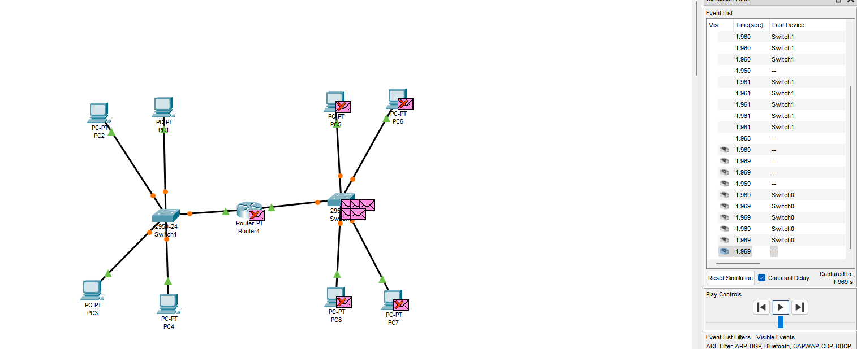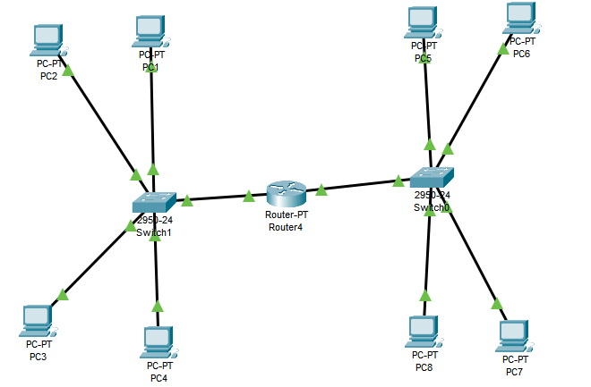**Part 1 to 6:**

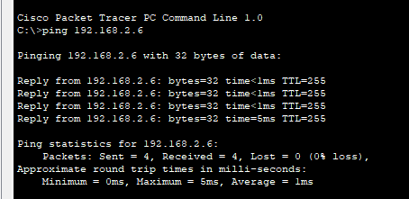**Part 7:**

**Part 8:**

**Question 2**

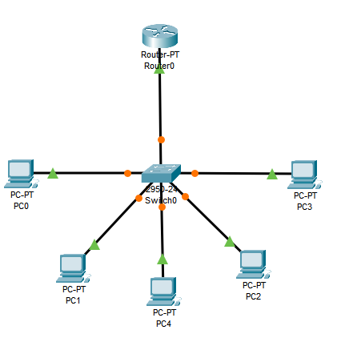

**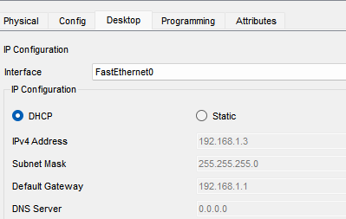  
PC after DHCP configuration:**